PRESS RELEASE
For Immediate Release
PINKFONG “BABY SHARK” LIVE MUSICAL IS COMING TO INDONESIA FOR THE FIRST TIME EVER!
New Musical Adventure, Pinkfong “Baby Shark” Live Musical Brings Pinkfong’s Viral Song And Dance Sensation to Life – On Stage – To Three Different Cities in Indonesia, Starting October 18th 2019
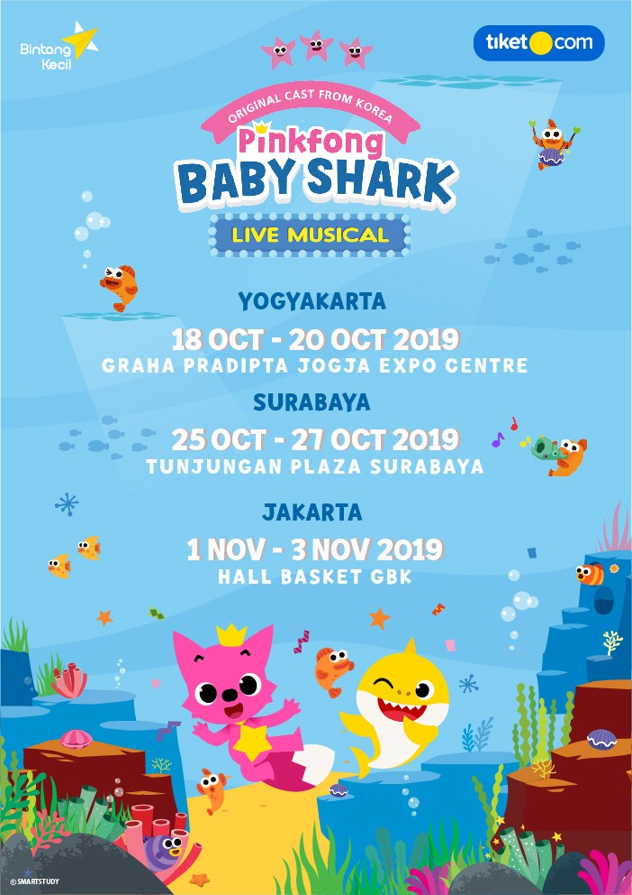

Jakarta, August 19th 2019 – Pinkfong and Promoter ‘Bintang Kecil’ proudly announce that “Pinkfong “Baby Shark” Live Musical”, a brand new fully immersive show experience, is scheduled to visit three (3) different major cities in Indonesia; including Yogyakarta, Surabaya, and Jakarta starting this October 2019. Fans are encouraged to visit www.pinkfonglivemusical.id in order to get more additional information when the tour starts this October!
The Shark Family has been living peacefully along with their marine neighbors, until the playful little Baby Shark disappears! Join Daddy Shark and Pinkfong in order to bring Baby Shark back! Here’s the schedule for “Pinkfong “Baby Shark” Live Musical”:
- Graha Pradita Jogja Expo Centre, Jogyakarta, October 18th – October 20th 2019
- Convention Hall Tunjungan Plaza, Surabaya, October 25th – October 27th 2019
- Basket Hall Senayan, Jakarta, November 1st – 3rd 2019
The live show is based on Pinkfong’s viral earworm and global dance phenomenon,‘Baby Shark’. This one of a kind concert experience will delight fans of all ages as Baby Shark joins up with his friend Pinkfong to take an adventure into the sea, singing and dancing through new and classic songs including Five Little Monkeys, Wheels on the Bus, Jungle Boogie, Monkey Banana Dance and of course, Baby Shark!
Baby Shark, Pinkfong’s global hit song about the shark family, has climbed the charts and connected with fans around the globe. After entering the Billboard Hot 100 at #32, the song has been recording a 174-week streak in the Top 50, while topping the Kids Digital Song Sales Chart as #1. The Baby Shark Dance video has over 3.2 billion views, making it the 7th most viewed video in the history of YouTube.
Roderick Tjandra, as the Managing Director of Bintang Kecil said, “We are extremely excited to be partnering with Pinkfong to bring a live version of their viral sensation Baby Shark throughout Jogjakarta, Surabaya, and Jakarta. It’s going to be a fun and engaging theatrical performance for the whole family to enjoy.”
Tickets for “Pinkfong “Baby Shark” Live Musical” can be purchased starting from August 21st 2019 via online at www.pinkfonglivemusical.id, www.bintangkecil.id, and www.tiket.com with the following categories based on the cities:
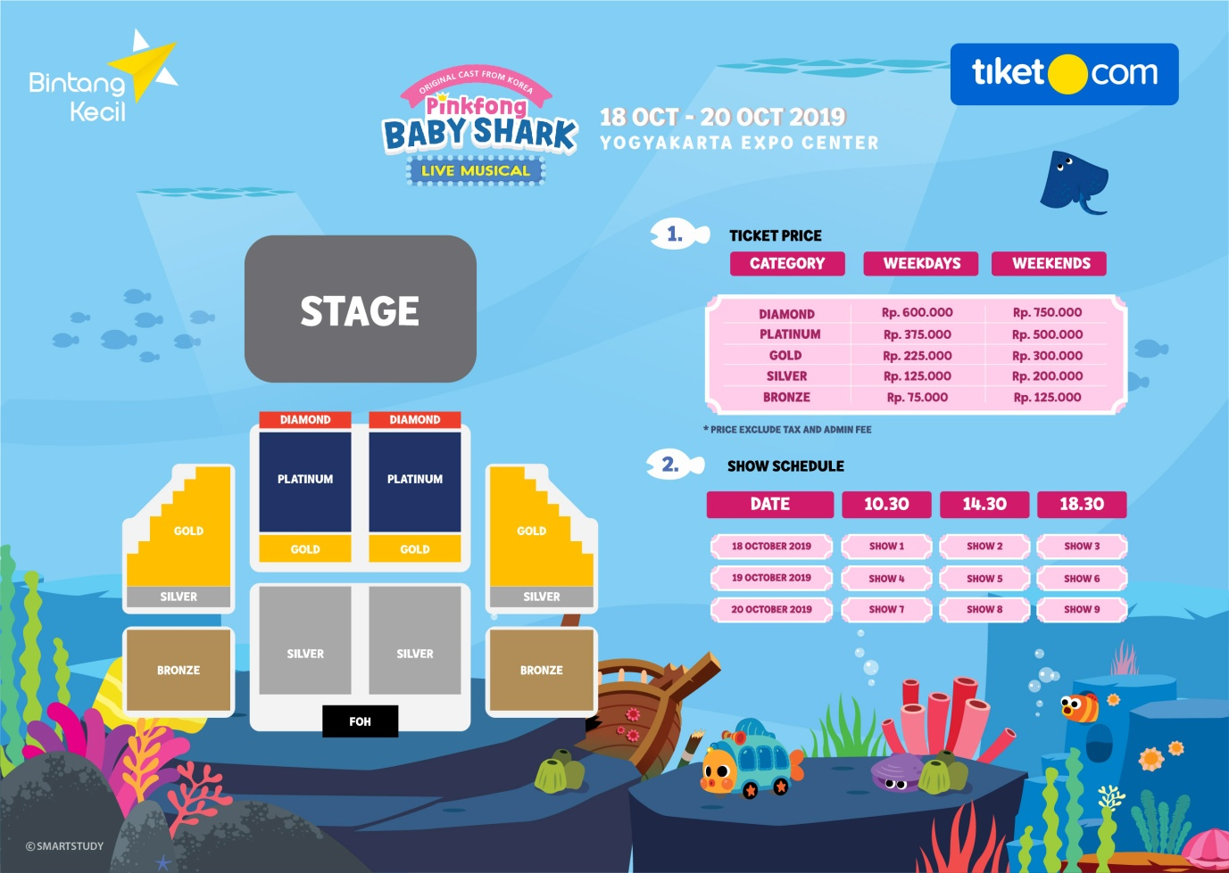

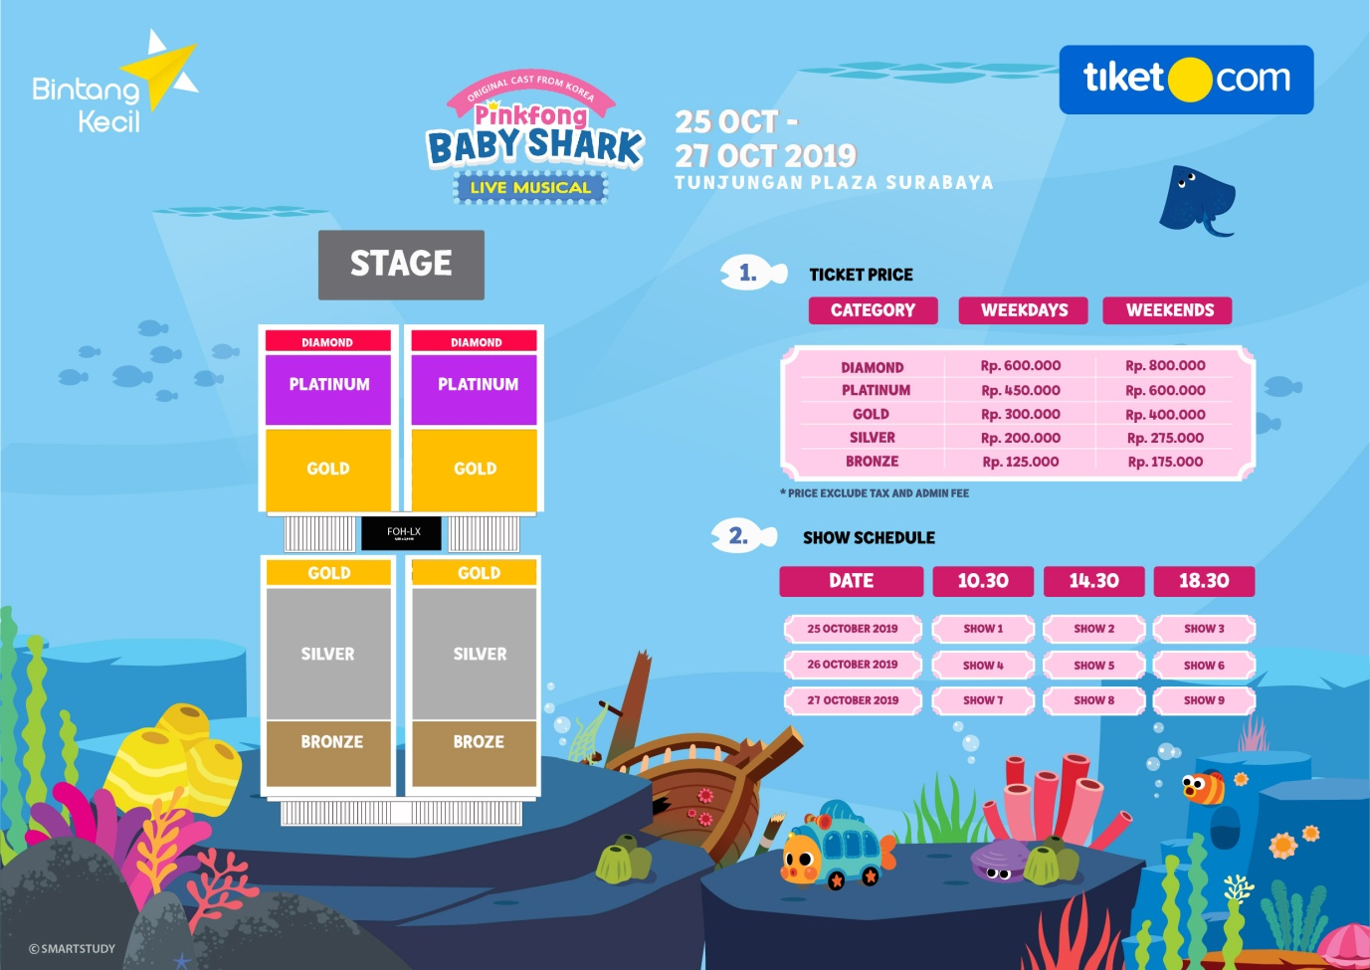
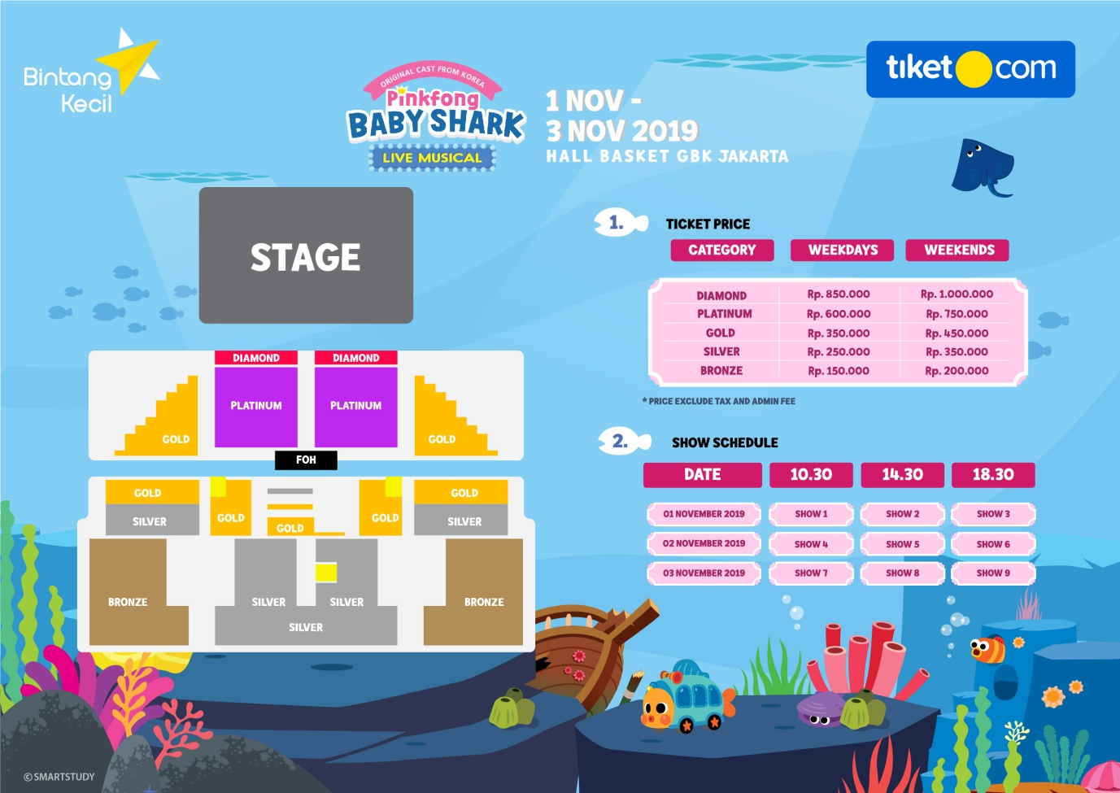
Join Pinkfong in the Adventure of Baby Shark in the Far Far Ocean, and Experience this Musical with your Loved Ones!
FOR MEDIA: Contact Munkee to schedule interviews,
secure photography or B-roll.
Munkee *Phone: 081 861 220 2 Email: Munkee@bintangkecil.id

About Pinkfong:
Pinkfong is a global entertainment brand that creates award-winning kids’ content for families around the world. Pinkfong has over 4,000 songs and stories within its vast library of children’s content, which can be accessed on the App Store and Google Play, as well as on YouTube and Amazon Video. Pinkfong’s accolades include the Amazon Video Direct Star, YouTube’s Diamond Play Button and Google Play’s Best Family App of 2014-2017.

